12/9/2018

2016-CE-60 2016-CE-72 2016-CE-74

Safina Yousaf Tooba Naseer Hina Maqsood

CS381L Software Engineering Term Project Final Report

Online Hotel Management

1. Introduction
   1. Purpose and scope:

Users may find it difficult to find the hotels in different websites. This app will allow them to filter hotels list easily. They can find all the hotels of Lahore in one place along with their prices, category, ratings and facilities.

Many people come from other countries and cities and they do not know about the hotels to stay so; this app will help them to find the best hotel.

* 1. Product overview:

The app contains basic search filtering for hotels of Lahore. In this app there are three stakeholders: Admin, Hotel Manager and User.

Capabilities and Scenarios:

This product can do specific tasks for Admin, Hotel Manager and User. Admin is allowed to do any changes in the overall application. If app is provided to the hotel manager, he can edit specifications, ratings, prices and facilities. User can do the searches and make his/her profile and edit it. Map is also provided in app so that user can easily find the hotel location. User’s feedback also matters a lot, if user provides any feedback about particular hotel then hotel managers of that hotel can see the feedback of user to do amendments accordingly.

1. Project Management Plan:
   1. Software Development Life Cycle:

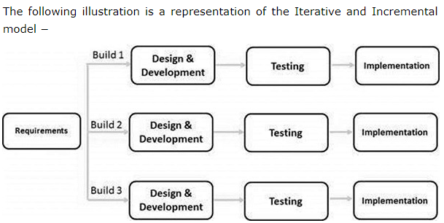

* 1. Commitment to SDLC:

We followed the Scrum model.

We worked through the requirement of developing new function after fully understanding the requirements we the designed the component and then we performed test on it. Porotype was also developed initially just to clarify the idea that what we are going to develop. We wrote Software requirements specification document.

* 1. Project Plan:

|  |  |  |  |  |  |
| --- | --- | --- | --- | --- | --- |
| Task name | Duration | Start | Finish | %Complete | Work |
| Software_Requirement Specification | 6d | 10/1/2018 | 10/6/2018 | 100 | 12h |
| Account_Management  (login/sign up) | 14d | 10/8/2018 | 10/21/2018 | 0 |  |
| Data_Mangement_of Hotels and searching | 18d | 11/1/2018 | 11/18/2018 | 0 |  |
| Filtration of Hotels  (Comparison) | 14d | 11/19/2018 | 12/2/2018 | 0 |  |
| Feedback Management | 7d | 12/3/2018 | 12/9/2018 | 0 |  |
| Email Notification | 7d | 12/10/2018 | 12/16/2018 | 0 |  |
| Linking_through Hotel’sOfficial Website | 7d | 12/17/2018 | 12/23/2018 | 0 |  |
| Maps Management | 7d | 12/24/2018 | 12/30/2018 | 0 |  |

* 1. Deviation from Project Plan:

GitHub was the main issue we faced, and it keeps on deviate to do our work on project. Sometimes it shows errors which we could not understand. Merge issues cannot be resolved easily. And the commits of one user are override by the commits of another member. But we tried our best to do the proposed work.

Each member of the group coordinated fully. We could easily understand each other and appreciate each other’s efforts.

* 1. Hardware and Software Resource Requirements:

This is a web application its Hardware requirements includes any device that support the web application that have any search engine it can be PC or Mobile. Software Requirements are same there should be a search engine to search the web that support html and internet must be available.

* 1. Impact of the Project on individuals and organizations:

Whenever we travel out of town the first problem we face is accommodation in affordable prices. So, we want to provide a platform where people can find room at better price through comparison moreover in this world of internet hotel business need exposure which will be provided to them through this website*.*

Customer satisfaction is motivation for this project. Save people from effort of searching hotel rooms by going door to door of hotels plus providing them best result by comparing prices plus they can read reviews of other customer*.* Whenever

User will come to visit Lahore he will not be worried about stay because he will find the best hotel at best price around him.

* 1. Team Coordination:

We properly divided the work and tried to complete our task. Any member did not hesitate to help the other member whenever she got stuck at any point in developing the software.

We kept our project synced with the help of git hub and looked for every possibility that we might get stuck. Git hub really slowed down our progress, but we tried hard to keep up. It is surely not the best we could deliver but because of shortage of time and lack of experience we could not do the estimated work.

1. Requirement Specifications
   1. Stakeholders for the system:

Stakeholder is a person or group who will be affected by the system, directly or indirectly.

In our case stakeholders are:

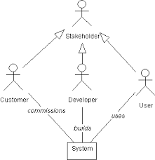

* 1. Actors for the system:

An Actor models a type of role played by an entity

That interacts with the subject, but which is external to object.

User:

Register itself as costumer log in to system and search for hotel he wants to visit, can add feedback and review.

Hotel Manager:

Register it, log in to system and add hotel data and maintain the record.

Admin:

Monitor the activities of user and Manger to avoid spam and harmful content.

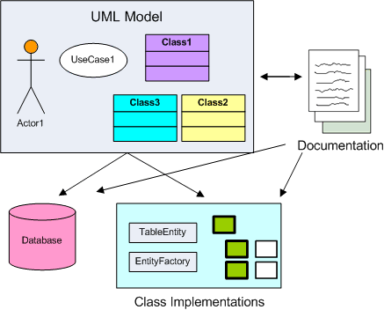

* 1. Use case model (Diagram Required):

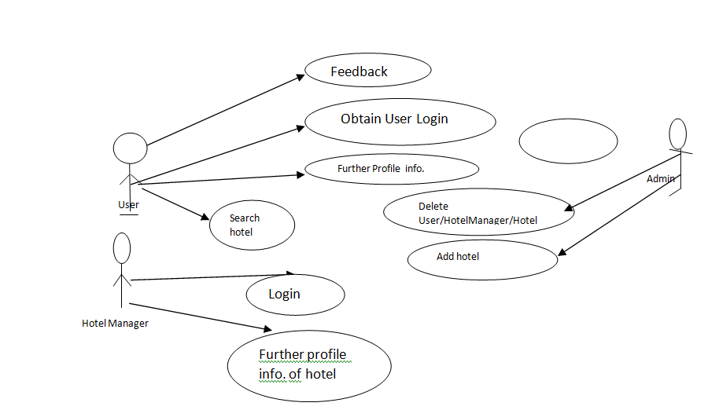

* 1. Textual Description for each use case:

|  |  |
| --- | --- |
| **Use Case Title** | **Signup for User** |
| **Use Case Id** | 1 |
| **Requirement Id** | 3.3.1 |
| **Description:** This use case is about adding a new user to existing system here user is required to fill a form that will be consisting of Name, Address , Contact etc. A user ID will be generated and sent to him via mail(required in contacts) and user will then continue to signup using mailed information. | |
| **Pre Conditions:**   * 1. User must have an Email account.   2. User must have Internet Connection. | |
| **Normal Flow** | |
| 1. User opens our Application. | |
| 1. User chooses for sign up in opened screen. | |
| 1. A sign Up form will appear where user enters his information. | |
| 1. User clicks Submit button an confirmation email is sent to user containing ID and password. | |
| 1. User continue to signup using that information and get registered against mailed ID by clicking continue to signup button appearing on sigh up form. | |
| **Alternative Flow** | |
| 4a. User don’t have email prior to signup  System must provide him with option to create email account.  4b.User want another way of confirmation of ID  System must provide confirmation through phone number option. | |
| **Post Conditions:**   * + New User account will be created against provided information. | |
| **Open issues:**  If user try to add email/phone number that is already occupied then user will not be added to system**.** | |
| **Authority:** User | |
|  | |
| **Use Case Title** | **User Log in to system** |
| **Use Case Id** | 2 |
| **Requirement Id** | 3.3.2 |
| **Description:** Here this case is about log in or sign in of user who want to avail services of hotel booking web Application. | |
| **Pre Conditions:**   1. User must have an Account. 2. User must have Internet connection. | |
| **Normal Flow** | |
| 1. User opens up our application. | |
| 1. User clicks Sign in button in opened menu. | |
| 1. If he is signing in for first time then system ask for email or ID and password. | |
| 1. If password and email or Id is right User dash board is opened. | |
| 1. And a remember me option will be provided to user so that he does not have to enter Email and password every time he log in. 2. Otherwise system will directly take him to his dashboard if he has not logged out last time. | |
| **Alternative Flow** | |
| 4a. User is not registered   * + System must provide and sign up option in case user is not already registered   4b. Forget Password  System must provide user with recovery password option. | |
| **Post Conditions:**   * + User is successfully logged in and directed to dash board. | |
| **Open issues:**  User is trying to access account which is not registered. | |
| **Authority:** All user that are Part of system. | |
| **Use Case Title** | **Managing the Profile** |
| **Use Case Id** | 3 |
| **Requirement Id** | 3.3.3 |
| **Description:** This use case is regarding maintenance of user profile. The user must be able to view information containing his name address contact and hotel he visited and reviews he gave about hotels. And he must have authority to delete any information or update it. | |
| **Pre Conditions:**   1. User must have an Account. 2. User must have internet connection. 3. User must sing in to his account. | |
| **Normal Flow** | |
| 1. User open up our website. | |
| 1. User sign in to his account. | |
| 1. Users profile us opened. | |
| 1. User search for hotel. | |
| 1. User Update, Add or delete any information. | |
| **Alternative Flow** | |
| 4a. Preventing of deletion of necessary information   * + If user tries to delete ID, Email or phone number then system must prevent him from doing this. | |
| **Post Conditions:**   * User must have an account. * User must have internet Connection. * User must Sign in. | |
| **Open issues:**  User tries to delete Email. | |
| **Authority:** User | |
| **Use Case Title** | **Hotel Searching** |
| **Use Case Id** | 4 |
| **Requirement Id** | 3.3.4 |
| **Description:** This use case is Associated with searching of hotels in Lahore.  User can either search by hotel name or search a by name of place and system will show all hotel situated near or on that place. | |
| **Pre Conditions:**  1. User must have internet connection.  2. User must sign in to his account.  3. User must search for hotels that are in Lahore. | |
| **Normal Flow** | |
| 1. User open up our site and log in. | |
| 1. User’s profile is open ups. | |
| 1. User clicks search option. | |
| 1. User enters Hotel’s name or name of place. | |
| 1. Searched hotel or list of hotels will appear from where user can choose. | |
| **Alternative Flow** | |
| 4a. User is new in city   * + Application must provide user with list of hotels by checking his location. | |
| **Post Conditions:**   * 1. List of hotels will appear where person can choose the best hotel according to his interest. | |
| **Open issues:**  User is trying to search hotel in other city or place that is not in Lahore. | |
| **Authority:** User | |
| **Use Case Title** | **Hotel Filtration** |
| **Use Case Id** | 5 |
| **Requirement Id** | 3.3.5 |
| **Description:** This use case is associated with filtration of hotel according to costumer interest that includes budget, luxuries, type of room etc. | |
| **Pre Conditions:**   * + User must have an account.   + User must have internet.   + User must sing in.   + User must Search hotels. | |
| **Normal Flow** | |
| 1. User opens up the web site and log in. | |
| 1. User search for hotel. | |
| 1. User must click the type of filter he want to use like luxuries, economy, low budget etc. | |
| 1. System will sort the hotel according to applied filter. | |
| 1. User can choose among them. | |
| **Alternative Flow** | |
| 4a. There is a problem when user clicks luxuries and low budget at same time   * + System must prevent this. | |
| **Post Conditions:**   * + 1. Sorted hotel list will appear on screen. | |
| **Open issues:**  If User choose to contrast option. | |
| **Authority:** Administrator | |
| **Use Case Title** | **User FeedBack** |
| **Use Case Id** | 6 |
| **Requirement Id** | 33.6 |
| **Description:** This use case is associated with user’s experience ant any hotels. It will help in filtration. | |
| **Pre Conditions:**   * + User must sign in.   + User must have leaved in that hotel. | |
| **Normal Flow** | |
| 1. User opens our website. | |
| 1. User login and directed to his profile. | |
| 1. User open his dashboard and click Feedback option. | |
| 1. Here a list of hotel appear where he lived or living. | |
| 1. User clicks hotel name and add, delete or update his feedback about hotel. | |
| **Alternative Flow** | |
| 4a. If user tries to enter feedback of hotel he has not lived in   * + System must prevent doing this. | |
| **Post Conditions:**   * 1. A feedback is recorded. | |
| **Open issues:**  If user gave two opposite view about same hotel different branch. | |
| **Authority:** User | |
| **Use Case Title** | **Linking to hotel website** |
| **Use Case Id** | 7 |
| **Requirement Id** | 3.3.7 |
| **Description:** When user click hotel name after applying filters a menu appeared. If user clicks Book room the control is rendered to official website of hotel where reservation is made. | |
| **Pre Conditions:**   * + User must sign in his account.   + User must search for hotels.   + User must apply filters for best result. | |
| **Normal Flow** | |
| 1. User open our website. | |
| 1. User log in to his profile. | |
| 1. User search for hotels. | |
| 1. User chooses a hotel from filtered list. | |
| 1. User is directed to official website of hotel where reservation is made. | |
| **Alternative Flow** | |
| 4a. Hotel website is not working   * + System must check for availability of hotels   Administrator continues from the step 3. | |
| **Post Conditions:**   * + - 1. User is linked to official website of hotel | |
| **Open issues:**  User try to access hotel with no official website | |
| **Authority:** Administrator | |
| **Use Case Title** | **Email Notification** |
| **Use Case Id** | 8 |
| **Requirement Id** | 3.3.8 |
| **Description:** When user room is reserved successfully through hotel’s official website record of hotel booking is added to user profile and an confirmation mail is sent to user. | |
| **Pre Conditions:**   * + User must sign in his account.   + User must search for hotels.   + User must apply filters for best result.   + User must reserve hotel though official website. | |
| **Normal Flow** | |
| 1. User open up his profile on our website. | |
| 1. User search for hotels and applies filter. | |
| 1. User clicks the hotel he liked from appeared list. | |
| 1. Hotel’s official website is opened. | |
| 1. User Book hotel there and return to his profile. | |
| **Alternative Flow** | |
| 4a. User don’t open his email   * + System must notify user to open email. | |
| **Post Conditions:**   * 1. A confirmation email is generated. | |
| **Open issues:**  If hotel canceled booking. | |
| **Authority:** Administrator | |
| **Use Case Title** | **Maps** |
| **Use Case Id** | 8 |
| **Requirement Id** | 3.3.8 |
| **Description:** This use case is associated to guidance for user. It will help most to user that is new in city so that application can show user list of hotels near to him. | |
| **Pre Conditions:**   * + User must sign in his account.   + User must have internet.   + User must turn on his location. | |
| **Normal Flow** | |
| 1. User open his profile on our website. | |
| 1. User turn on his location. | |
| 1. User will have to choose search around me to use pin to filter hotels for him. | |
| 1. User will select hotel that is already booked. | |
| 1. By clicking the map icon user will directly moved to direction for selected hotel. | |
| **Alternative Flow** | |
| 4a. There is a problem when maps are down due to any reason   * + System must keep record of most visited hotel to prevent this issue | |
| **Post Conditions:**   * + 1. User will get direction or hotel list. | |
| **Open issues:**  What if user is not in Lahore at the time he is booking hotel. | |
| **Authority:** Administrator | |

* 1. Non-functional requirements:

Nonfunctional requirements are those requirements of software system through which criteria are defined to check operation of system instead of specific behavior.

### Performance Requirement:

It relates with the response time of system.

* System should not take more than 3 seconds to show result of any query.
* System should link user with Hotel’s official website in 2 seconds.
* Email should be sent to user within 5 seconds after the reservation is made by him.

### Logical Database Design:

Following data elements will be part of system database along with other required data elements.

### Provider:

* Client’s Name
* Client’s Address
* Client’s Email
* Client’s Phone Number
* Hotel’s Stayed in
* Hotel Reviews

### Client’s database

* Hotel Name
* Hotel Address
* Room Number
* Room Type
* Check in date
* Check out date
* Total Bill
* Reviews

1. Design:
   1. GUI:

Graphical User Interface of our project is like:

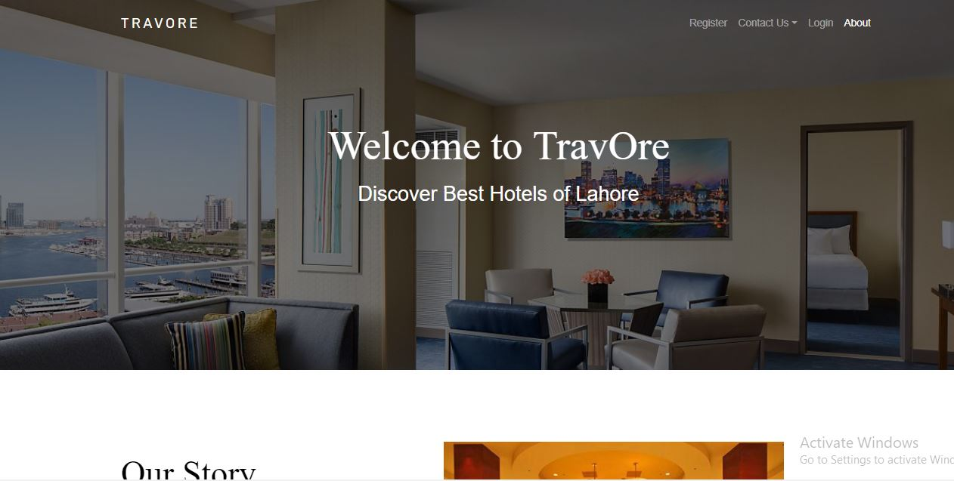

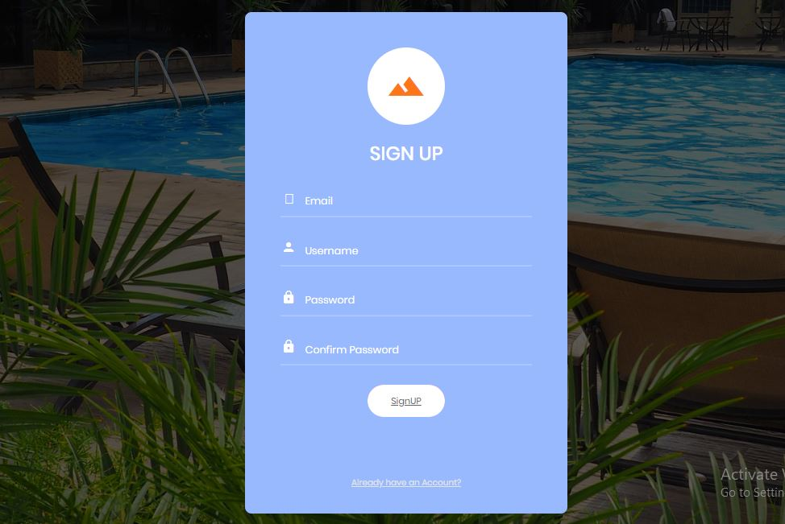

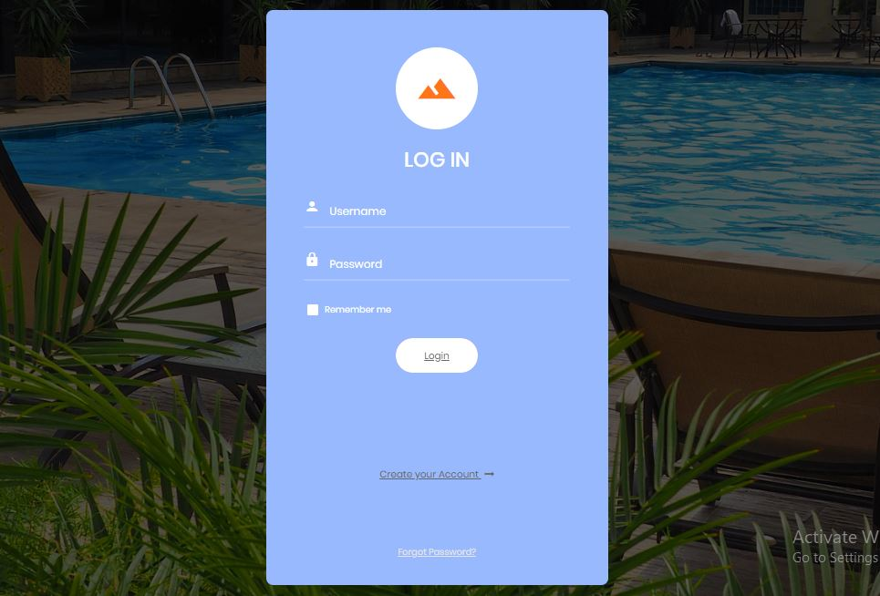

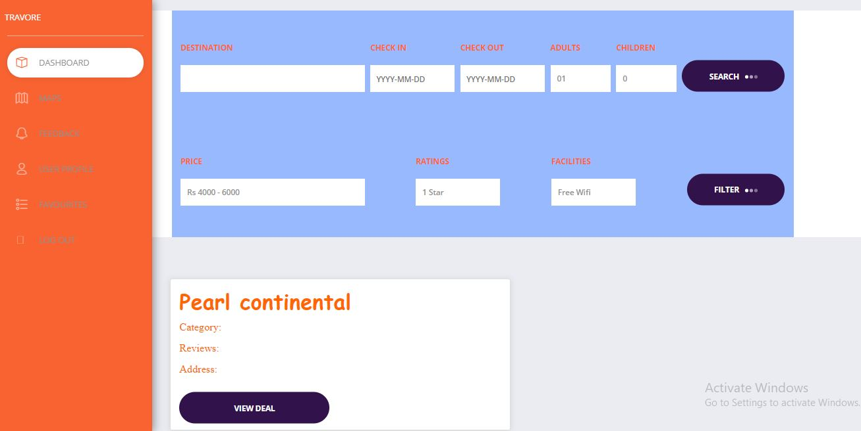

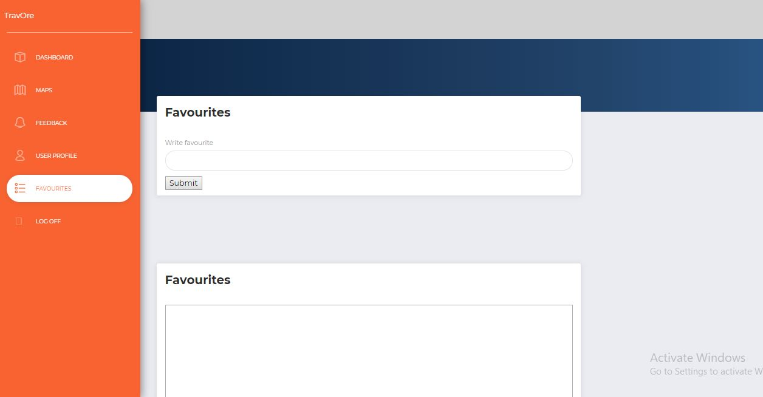

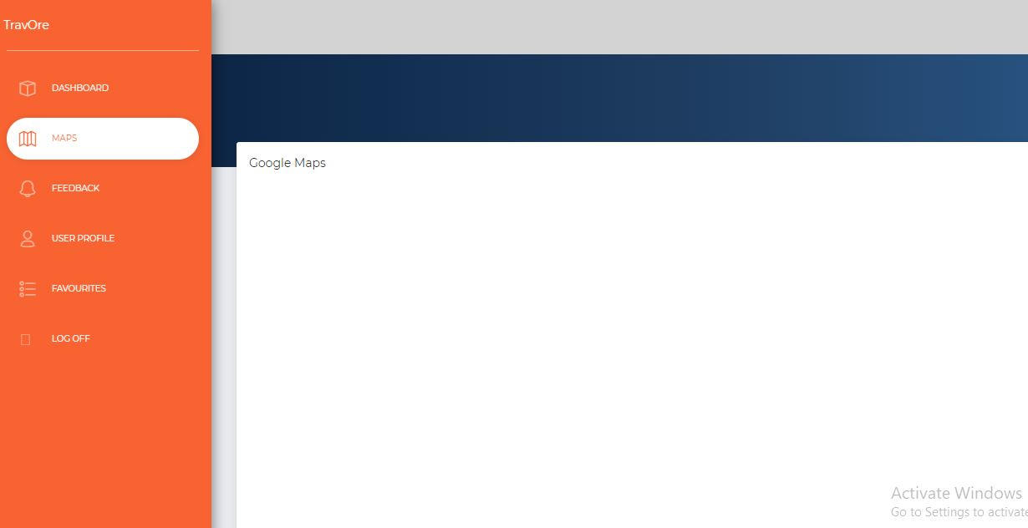

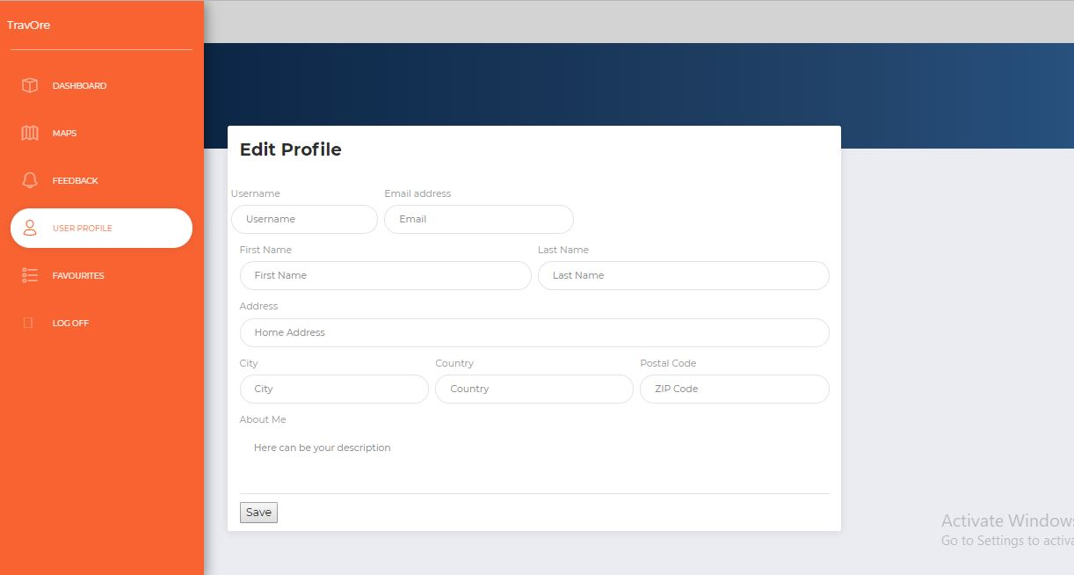

* 1. Deviation from proposed GUI:

GUI of project is slightly different from proposed GUI. Screens of proposed GUI is as below:

User Interfaces:

We have made prototype of website using the software named Just In Mind. It is highly recommended and easy to use to form the predicted screen of any kind of application.

**Screen 1:**

The user interface will be very handy and interactive. Different kinds of screens will be used.

Firstly, there is a screen of our website mentioned its mane and logo. On that screen a button is showed to sign up for the new comers and login for already registered students.

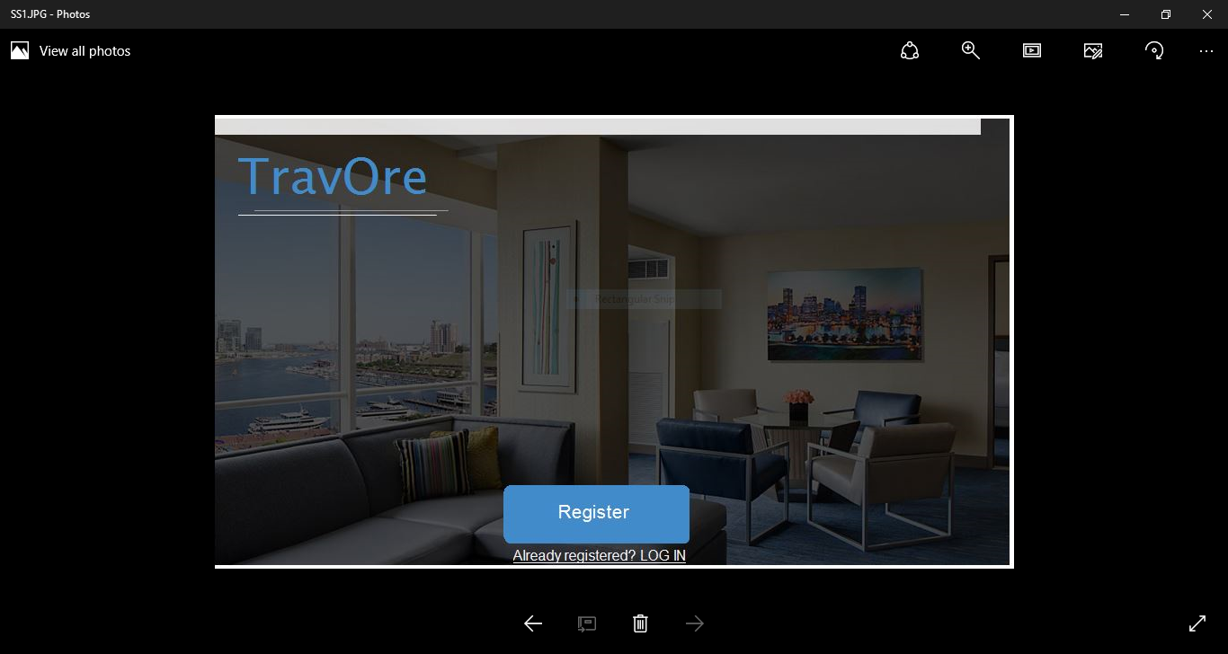

**Screen 2:**

This screen consists of sign up and user will easily have registered himself/herself to our website through giving some information such as user name, email address, password, confirm password.

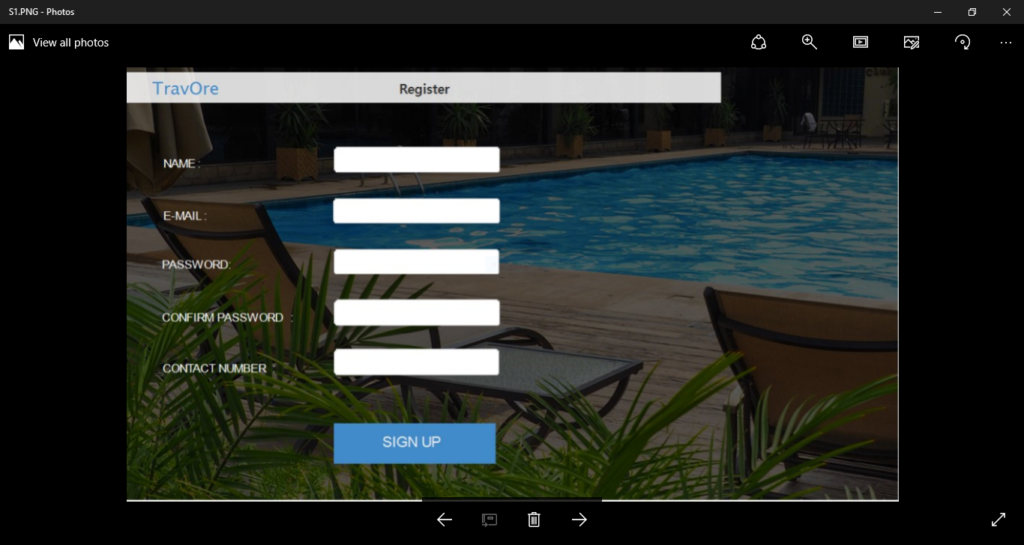

**Screen 3:**

This screen consists of login details of already registered users. They will only give email and password to access the website and profile.

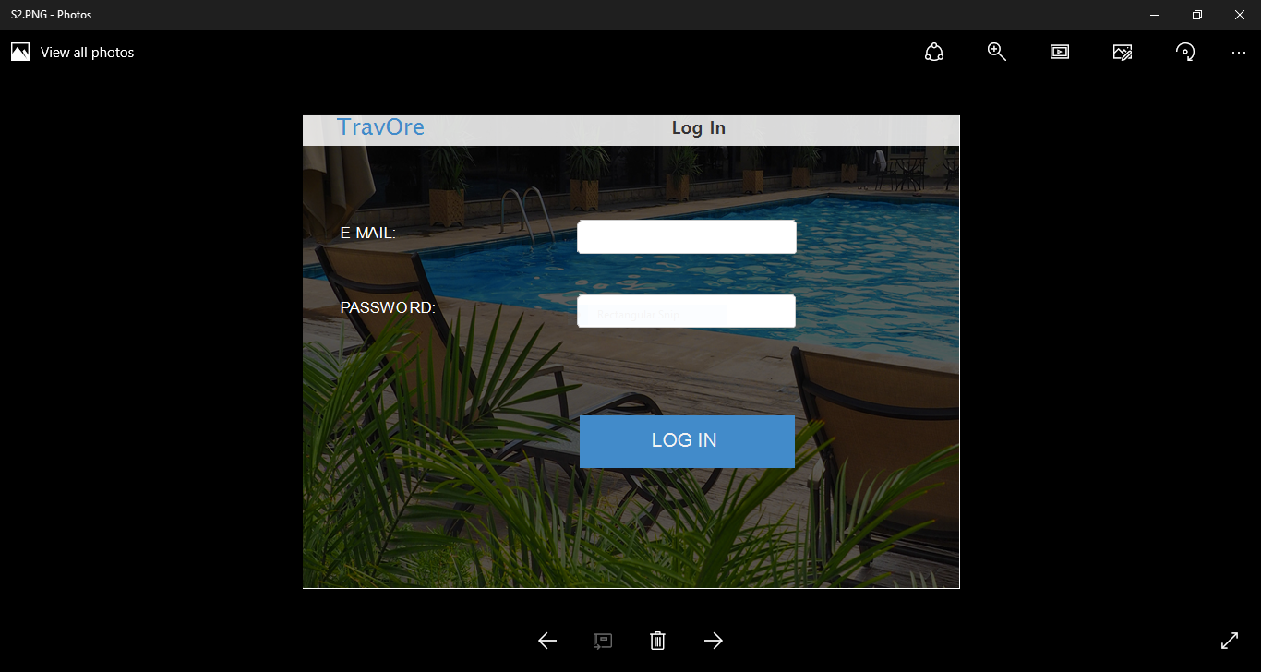

**Screen 4:**

A search bar can be opened to search nearby hotel in your area. A checkout and check-in details also given with the help of calendar. An icon is also attached by clicking it a map will be opened to view the exact location of the hotel. After searching the hotel, a new screen is appeared having the details of that hotel.

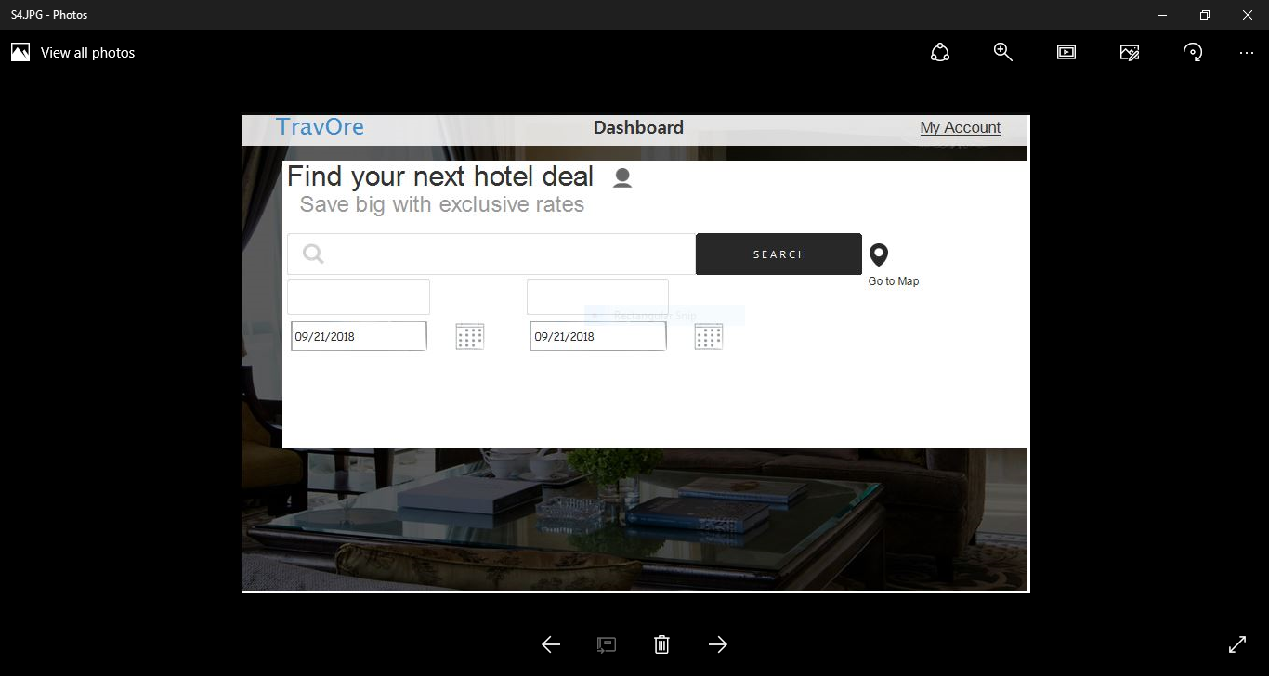

**Screen 5:**

My Account will appear after login. There a user can easily find the information of his profile. He can be free to reform his profile details. Here links of other screens are also available to shift from one screen to another. It is having a list of bookings, Review, Dashboard, Settings, Favorite Hotels, and Logout. Through Logout button the user will exit from the website and Go to first screen.

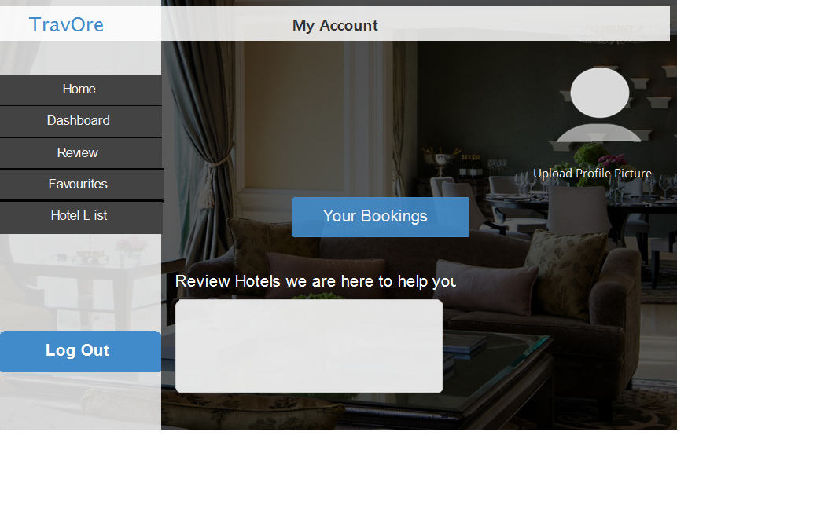

**Screen 6:**

If a user not entered a specific hotel in search bar he can also open the list of Lahore Hotels then from there he can easily choose ant hotel to view the details of hotels, availability of rooms, facilities.

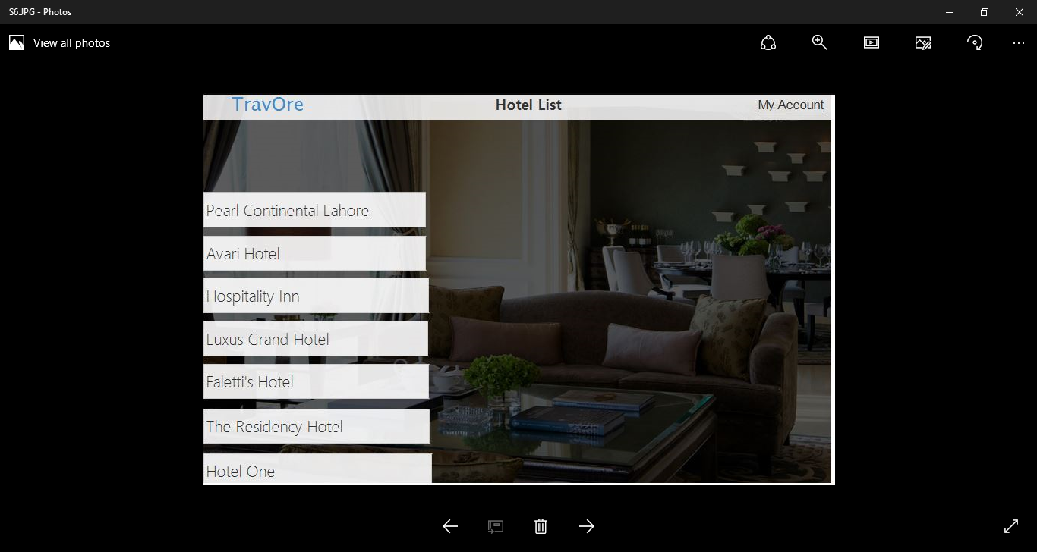

Screen 7:

After choosing a hotel a screen will be appeared where a user can view the details of the hotel and at this screen a link of the official website of hotels is provided where user can easily book the hotel. Actually our website is similar to (foodPanda) a well-known website of food ordering. If a customer is having any issues regarding booking he can review and comment for complaining to our website.

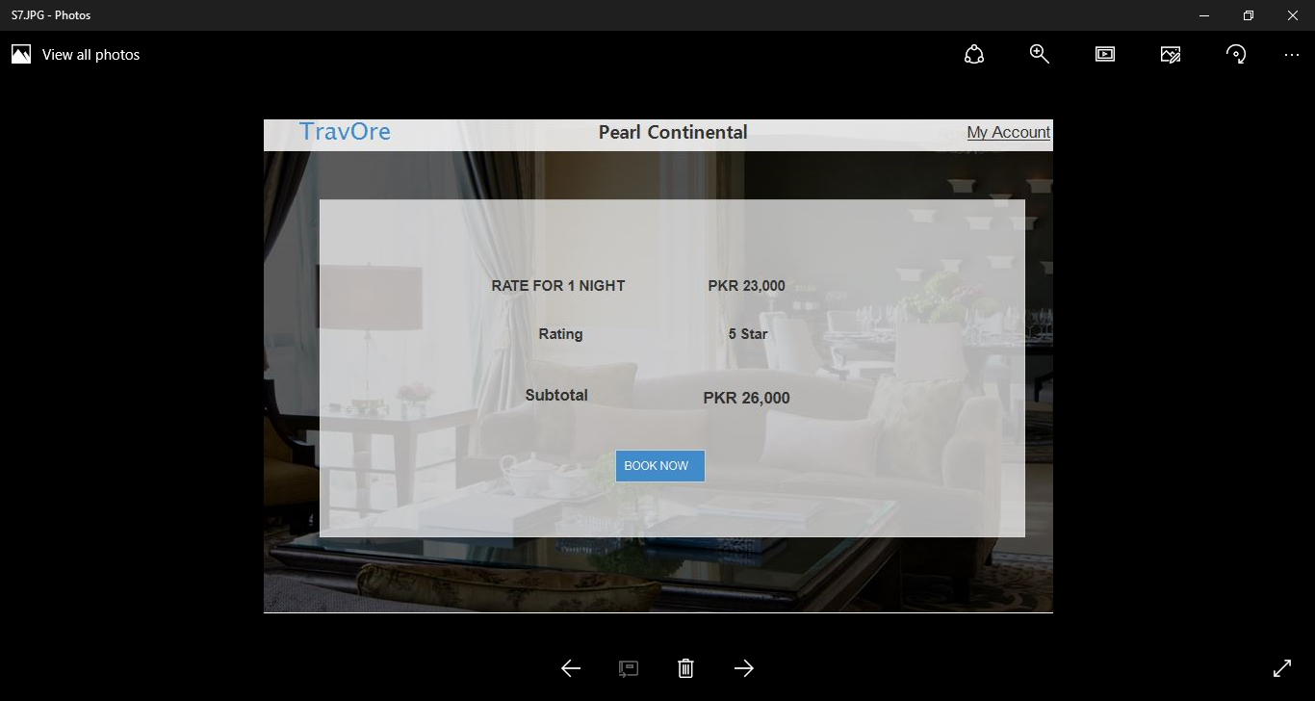

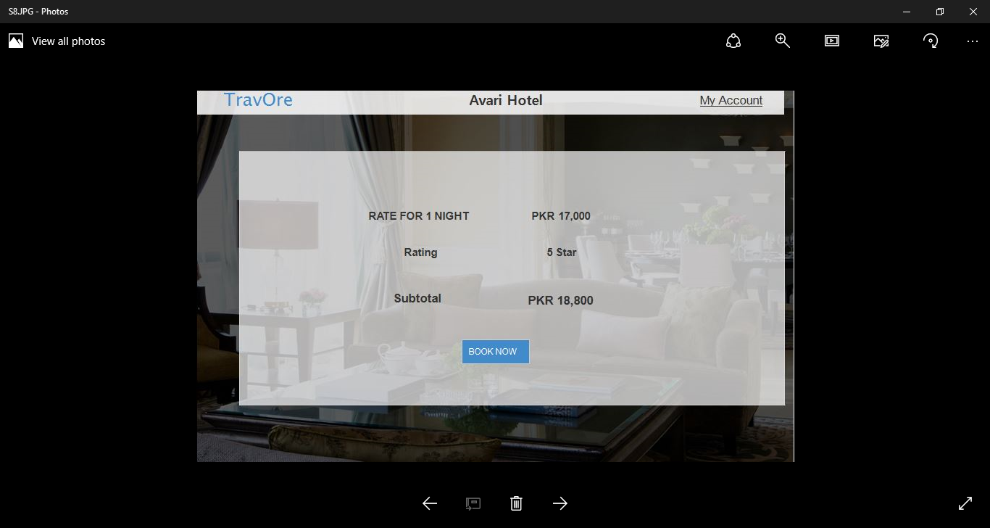

* 1. Static model – Class Model:

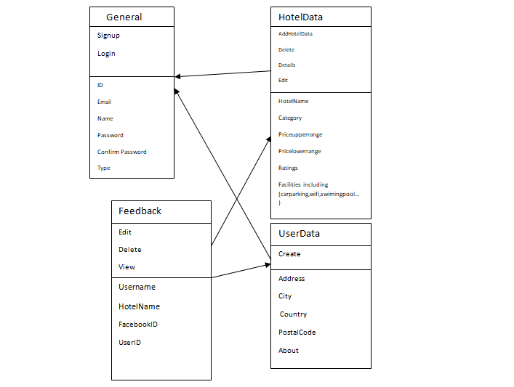

* 1. Database Diagram: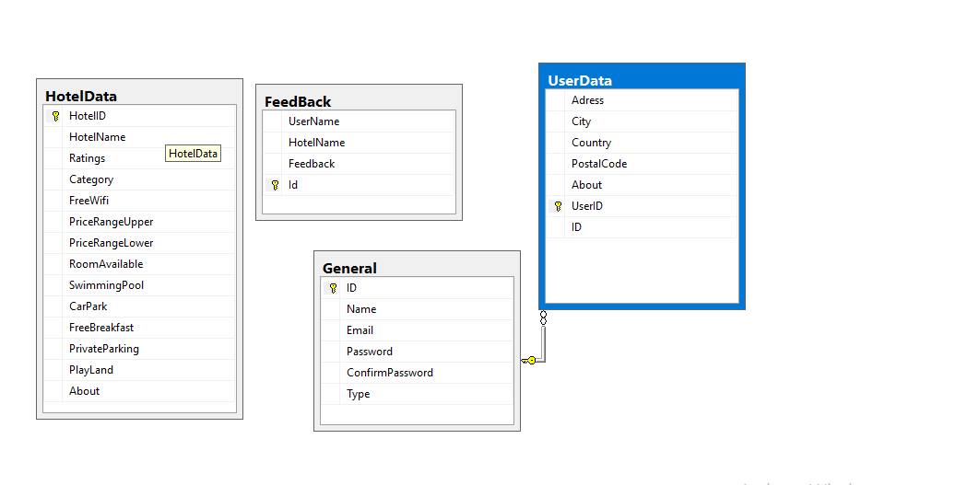

1. Testing of Project
   1. Test Plan for your system:

Analyze the product:

Firstly, product will be analyzed based on user or market demand. We will give them a demo or prototype to analyze that do they see the required functionality in the software interviewing the client, getting their feedback and walkthrough the product as user will help us analyze the flaws.

Test Strategy:

We will target the scope of product and identify the main functionality without which our app is useless.

In our case we performed the following testing:

Unit Testing:

We checked for each method output that if it works according to our desire.

Integration Testing:

As it was a team project different component are built by different team members we integrated them and perform integration testing to see if they work the way e want them to work.

System Testing:

In the end we performed test on system as a whole that the percentage of system we were able to build is working properly or not We then removed and tried to remove flaws from our software.

1. Deployment
   1. Link to git hub repository:
   2. Deployment Plan of System: